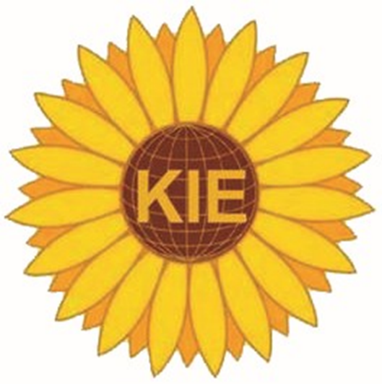

Kansas International Educators Conference

Kansas City Kansas Community College

April 3, 2025

9 a.m. – 3 p.m.

* 8:00 a.m. – 9:00 a.m. Registration
* 9:00 a.m. – 9:30 a.m. Opening Ceremony
* 9:45 a.m. – 10:45 a.m. Session One
* 11:00 a.m. – 12:00 p.m. Session Two
* 12:00 p.m. – 2:00 p.m. Luncheon Ceremony with Speaker
* 2:00 p.m. – 3:00 p.m. Session Three